EASTERN INTERNATIONAL UNIVERSITY Practice Assignment – Quarter 1, 2024-2025
SCHOOL OF COMPUTING Course Name: OOD
AND INFORMATION TECHNOLOGY Course Code: CSE 203
g&h Student’s Full Name:
Student ID:
Lab 7
- Singleton Pattern

Objective:
- Implement a Singleton class to ensure only one instance of a resource exists.

Task:
- Create a Logger class:
  - Ensure it has a private constructor.
  - Use a static method getInstance() to return the single instance.
  - Add a method log(String message) to print messages with timestamps.
- Write a main program:
  - Retrieve the Logger instance multiple times and log different messages.
  - Verify that all messages are logged using the same instance.

Expected Output:
- Logs should show timestamps and be consistent across the application, ensuring one instance of Logger.
Hint: the log method could be:
// Method to log messages with a timestamp
public void log(String message) {
String timestamp = LocalDateTime.now().format(DateTimeFormatter.ofPattern("yyyy-MM-dd HH:mm:ss"));
System.out.println("[" + timestamp + "] " + message);
}
- Factory Pattern

Objective:
- Design a Factory to create different types of objects dynamically.

Task:
- Create an interface Shape with a method draw() (should a simple void method printing a message like “drawing a Circle”...).
- Implement Circle, Rectangle, and Square classes that implement Shape.
- Implement a ShapeFactory class with an abstract method getShape():
  - Return an instance of a shape.
- Implement CircleFactory, RectangleFactory, and SquareFactory classes that implement ShapeFactory and return appropriate shape objects in the getShape method.
- Write a main program:
  - Use classes to create shapes based on user need and call their draw() methods.

Expected Output:
Different shapes should display messages like:
- "Drawing a Circle"
- "Drawing a Rectangle"
Hint: Students can use the following UML:
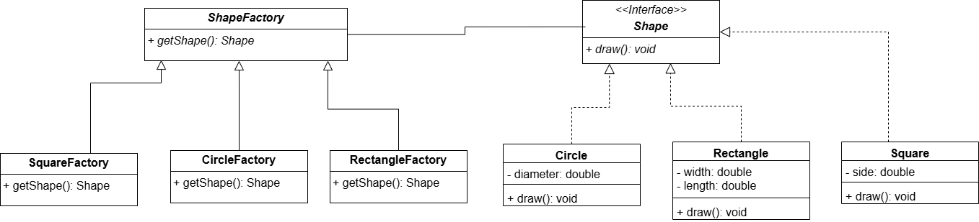
- Decorator Pattern

Objective:
- Extend the functionality of an object dynamically.

Task:
- Create an interface Coffee with a method getCost() and getDescription().
- Implement a basic SimpleCoffee class.
- Create a base class named BaseDecorator which should have a Coffee attribute as well as extends the Coffee interface.
  - Create decorators like MilkDecorator, SugarDecorator, and WhippedCreamDecorator. These class should extend the BaseDecorator class and add a specific feature and cost to the coffee.
- Write a main program:
  - Start with SimpleCoffee and dynamically add milk, sugar, or whipped cream.
  - Print the final description and cost.

Expected Output:
For example, ordering coffee with milk and sugar should output:
- "Description: Simple Coffee + Milk + Sugar"
- "Cost: $4.50"
- Strategy Pattern

Objective:
- Implement a family of algorithms and make them interchangeable.

Task:
- Create a ShoppingItem class which has fields to store description and cost of shopping items
- Create an interface PaymentStrategy with a method pay(double amount).
- Implement strategies like CreditCardPayment, PaypalPayment, and CashPayment.
- Create a ShoppingCart class:
  - Hold a list of items and calculate the total price.
  - Hold and accept a PaymentStrategy object to process the payment.
- Write a main program:
  - Add items to the cart and choose different payment strategies to pay.

Expected Output:
For example:
- "Total amount: $100"
- "Paid $100 using Credit Card"
- Observer Pattern

Objective:
- Create a publish-subscribe mechanism to notify observers about changes.

Task:
- Create an interface Observer with a method update(String message).
- Create a Subject class:
  - Maintain a list of observers.
  - Methods: addObserver(Observer observer), removeObserver(Observer observer), and notifyObservers(String message).
- Implement concrete observers like EmailSubscriber and SMSSubscriber.
- Create a NewsAgency class extending the Subject class
- Write a main program:
  - Simulate a NewsAgency that publishes news and notifies all subscribers.

Expected Output:
When the NewsAgency publishes news, observers should receive it:
- "Email Subscriber: Breaking News!"
- "SMS Subscriber: Breaking News!"

Submit: Must include:
- a pdf file containing your information (student id, name), and images of the class diagrams, codes, answers
- and all source code files (if any)
in a zipped (.zip or *.rar) file to Moodle

